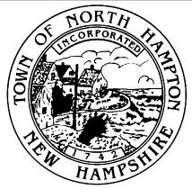
Town of North Hampton, New Hampshire
North hampton recreation commission
agenda March 17, 2015
mary b. herbert conference room – 5:30 PM

- Call to Order

- New Business

2.1 Egg Scramble
2.2 Summer Recreation
2.3 Piano Lessons

- Closing Comments
  - Closing Comments by Visitors
  - Closing Comments by Recreation Commission Member

- Adjournment

